The Pearl Webquest
Welcome to the first part of our WEBQUEST! I hope this will be a fun and interesting way for us to study a work by one of America's greatest authors, John Steinbeck.
Task #1 This part of our webquest involves working with a website to find information about the author of The Pearl. You should go to the websites listed below, read about Steinbeck, and jot down some notes. Once you have learned about Steinbeck, you will take a quick quiz, and then create a timeline.
The quiz must be completed by the end of the hour and turned in to the teacher. You will only have this period to complete this task. Work quickly and quietly. Students found using other websites other than those listed below will be asked to log off and will take a zero for this assignment.
After you have finished the quiz, get started on the timeline.
You will need to visit the following websites in order to answer the questions below.
http://nobelprize.org/nobel_prizes/literature/laureates/1962/steinbeck-bio.html
http://www.notablebiographies.com/Sc-St/Steinbeck-John.html
http://www.americanwriters.org/writers/steinbeck.asp (There is also a movie about him on this website.)

Now that you have read about John Steinbeck, and clarified what you know about him, it’s time for the next step. You will create a time line of events in Steinbeck´ s life that might have influenced the depiction of his characters. Feel free to refer back to the websites listed above to research John Steinbeck´s family background and life. Select things you believe influenced him the most.
- Prepare a list of important dates and events that took place in Steinbeck´ s lifetime. Be prepared to explain what influence these events might have had in his writing
- Create a time line of these events.
- Be prepared to present your findings to the class.

How You Will Be Graded
Criteria | yes | no
Dates are accurate.
Dates reflect influence on writing.
Time line prepared neatly
At least five images/symbols are used in connection with the timeline
Thoroughness -- Key events of Steinbeck’s life are covered.
- Revise until all answers are yes.
Name: ___________________________________ Date: ___________________________ Period: _________
JOHN STEINBECK TRIVIA QUIZ
1. When was John Steinbeck born?
a. 1902
b. 1904
c. 1920
d. 1934
2. Steinbeck attended which University?
a. Harvard University
b. Stanford University
c. San Jose State University
d. He didn’t attend college
3. What was Steinbeck’s first published novel?
a. The Grapes of Wrath
b. Cannery Row
c. The Red Pony
d. Cup of Gold
4. Which of the following Steinbeck books take place in Monterey?
a. Tortilla Flat
b. Cannery Row
c. Sweet Thursday
d. All of the above
5. During World War II, Steinbeck:
a. Was a war correspondent in Europe and
Northern Africa
b. Fought in many battles in Italy
c. Stayed in the United States and wrote fiction
d. None of the above
6. Who did Steinbeck travel across the United States with in 1960?
a. His wife
b. His friend Ed Ricketts
c. His dog Charley
d. He traveled alone
7. Steinbeck received which of the following awards?
a. A U.S. Postal stamp was issued in his honor
b. The Pulitzer Prize
c. The Nobel Prize
d. All of the above
8. John Steinbeck died in:
a. 1960
b. 1962
c. 1950
d. 1968|
9. John Steinbeck’s ashes are buried in:
a. Sag Harbor, New York
b. Somerset, England
c. Salinas, California
d. Monterey, California
NAME THE BOOK! The following questions test your knowledge of John Steinbeck’s books.
10. In which of his books does Steinbeck capture the characters and atmosphere of the Monterey shoreline?
a. East of Eden
b. The Red Pony
c. The Pearl
d. Cannery Row
11. Which book tells the epic story of two American families, the Trasks and the Hamiltons, and takes places mostly in Salinas, California?
a. The Red Pony
b. East of Eden
c. The Grapes of Wrath
d. The Winter of Our Discontent
12. Which book is Steinbeck’s classic novel about Dust Bowl migrants and their difficult journey to find a work and a happy life in California?
a. Tortilla Flat
b. In Dubious Battle
c. The Grapes of Wrath
d. Of Mice and Men
13. Which book is about two men, George and Lenny, who are drifting ranch hands in the Salinas Valley?
a. In Dubious Battle
b. The Red Pony
c. Travels with Charley
d. Of Mice and Men
14. Which book is an old Mexican folk tale about greed and misfortune after a fisherman named Kino makes a rare discovery?
a. The Forgotten Village
b. Viva Zapata!
c. The Pearl
d. Travels with Charley
15. Which book is about a boy named Jody growing up on a small ranch in the Salinas Valley?
a. The Red Pony
b. Of Mice and Men
c. The Pearl
d. The Short Reign of Pippin IV
16. Which book is about a leader in the
Mexican Revolution?
a. The Pearl
b. Viva Zapata!
c. Travels with Charley
d. Tortilla Flat
Questions courtesy of the John Steinbeck Center http://www.steinbeck.org/MainFrame.html
Task #2: Our next task will utilize the Jigsaw method to collect, analyze and distribute information which will be useful in our reading of The Pearl. This information, when put all together, will explain some important concepts/items in the novel.
Part One - Research: You and your group (I will assign them) will gather information about one topic relating to the novel. Together you will evaluate the websites where you find information, determine what information will be useful for the task, and, finally be prepared to report to members of other groups. The report you give to other students will be the only access they have to the topic you and your jigsaw group are researching. Although some websites have been listed for you under the group sections, you may also want to use search engines to find other useful sites as well.
The links below will help you analyze web sources and will help your group to manage its time.
http://webquest.sdsu.edu/processguides/evaluating_student.html
http://webquest.sdsu.edu/processguides/time_manage.html
Please print one copy of each of these documents, read it together as a group, and initial the document to indicate that you have read and understood the information presented.
Part Two – Presenting your Research: Now that your group has gathered the information, write an interesting presentation that you can share with members of the class who did not belong to your group. You may want to use some graphic elements like charts, diagrams, or pictures to illustrate the information. You can create a PowerPoint, a poster or use another presentation technology of your choice (glogster.com, google presentations, etc.).
Group Members:

Group 1 – Scorpions
- Matt Borton
- Nicco Consolino
- Jeremy Hill
- Marcelo Hunka
- Matt Ranger
Group 2 – Pearls
- Austin Barnes
- Lia Cavalcante
- Jordan Miller
- Juliana Oviedo
- Logan Thiel
Group 2 – Pearl Diving
- Alicia Diaz
- Shayna Hess
- Lalita Martsuwan
- Ashley Quigley

Group #1 You are responsible for researching scorpions. Find out the following things about them prepare the information so that you can share it with others. You can use glogster.com, Power Point, or some other online tool to share the information.
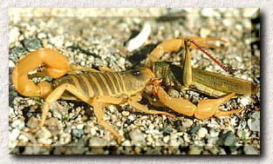
What do they look like? Where do they live? What do they eat? How do they hunt their prey? Are they dangerous to humans? Why or why not?
How many varieties of them are there? Do they have any natural enemies? What should people do if they encounter a scorpion? What if a person is stung?
In addition to answering these questions, include four interesting facts you discovered during your research.
You will find useful information about your topic at the following websites:
- http://insects.tamu.edu/extension/bulletins/l-1678.html
- http://www.desertusa.com/oct96/du_scorpion.html
- http://animals.nationalgeographic.com/animals/bugs/scorpion/
- http://cals.arizona.edu/pubs/insects/az1223/
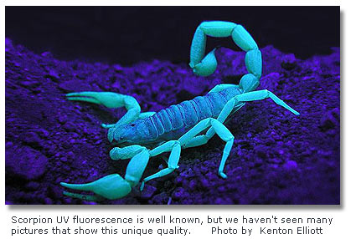
Group #2 You are responsible for researching pearls. Find out the following things about them prepare the information so that you can share it with others. You can use glogster.com, Power Point, or some other online tool to share the information.

Where do pearls come from? How do they form? What do they look like? How can you tell a real pearl from a fake one? What are marine pearls? What are cultured pearls? What are La Paz pearls? What are imitation pearls? What is the history of pearls in North America? What is the silver-lipped pearl oyster?
In addition to answering these questions, include four interesting facts you discovered during your research.
You will find useful information about your topic at the following websites:
- http://www.amnh.org/exhibitions/pearls/
- http://www.amnh.org/education/resources/pearls/pearlsinsert.pdf
- http://animals.howstuffworks.com/marine-life/question630.htm
- http://www.fieldmuseum.org/pearls/
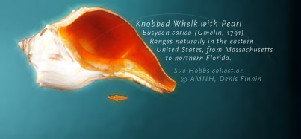
Group #3 You are responsible for researching pearl diving. Find out the following things about them prepare the information so that you can share it with others. You can use glogster.com, Power Point, or some other online tool to share the information.
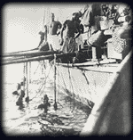
What dangers do pearl divers face? What kinds of people were pearl divers? What kind of life did pearl divers live? How do pearl divers adapt their bodies to the ocean? What are the bends? What is pearl culturing? What is the history of pearl diving in the Pacific? How is the quality of a pearl judged?
In addition to answering these questions, include four interesting facts you discovered during your research.
You will find useful information about your topic at the following websites:
- http://www.amnh.org/exhibitions/pearls/obtain/index.html
- http://library.thinkquest.org/10236/div.htm
- http://www.sheikhmohammed.co.ae/english/history/history_pearl.asp
- http://www.divingheritage.com/pearldivingkern.htm
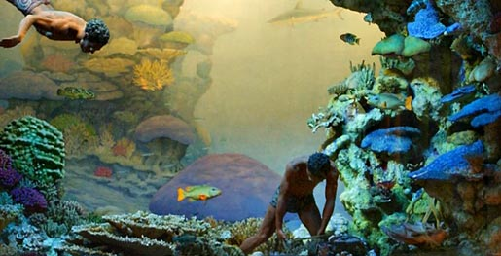

Extra Credit Activities
You may select one of the following two activities to complete for extra credit: Diary Activity or Condolence Letter.

Diary Activity

Introduction
Congratulations! You have just won a very large sum of money. Will your life change now? Everyone knows you have won the lottery.
Note: With your teacher, please review your school's acceptable use policy for work on the Internet. Also, links to the web often change. Tell your teacher when you find a poor link in this guide.

The Task: Create a Diary About Winning Big
Explain how your win will affect your life. Will you travel around the world? Buy a new house? How will others treat you? What types of problems might you encounter? How will the wealth change you?
To explore these issues, you will create an imaginary diary for the events of five days in your life. Two of the the days will be before your big win, and three days will be after you receive the money.

The Process: Exploring the Web, Creating a Product
Write diary entries for two days of your life now.
Each diary entry should have a date and at least two paragraphs about the day.
Write your diary in the first person.( I/we). Include
- normal activities
- feelings
- thoughts
• Research and read some reports on big money winners to get an idea for what they experience.
Pretend you are a big money winner. Add three entries to your journal after the big win.
  - Include:
    - the events
    - your emotions
    - thoughts
Revise and edit your diary before you hand it in.
Use your imagination to make your paper diary look like a real diary.
  - Each diary entry should have a date and at least two paragraphs about the day.
  - Entries should reflect any emotional, mental, or physical changes you undergo in the process of acquiring the money., or after you receive it.
  - Your entries should describe a pattern in the lives of the winners--an idea that you have drawn from your readings

How You Will Be Graded
Criteria | yes | no
Dates are included.
Resembles a diary.
At least, two paragraphs are written per entry.
There are five entries
There is a pattern in the lives of the winners as reflected in your readings
Revise until all answers are yes.

Condolence Letter

Introduction
Juana and Kino´s child is dead. Imagine their great sense of loss. A thoughtful letter of condolence is both a tribute to the deceased and a source of comfort and courage to the living.
Note: With your teacher, please review your school's acceptable use policy for work on the Internet. Also, links to the web often change. Tell your teacher when you find a poor link in this guide.

The Task:Write a Letter of Condolence
Compose a letter to Juana and/or Kino expressing your sadness over their loss. A good letter is like a visit on paper. Use your usual vocabulary and phrasing.

The Process: Exploring the Web, Creating a Product
A letter of condolence should:
- Acknowledge the loss
- Express your sympathy
- Note special qualities of the deceased
- Recount a memory about the deceased
- Note special qualities of the bereaved (the person who is sad about the loss)
- Offer assistance
- Close with a thoughtful word or phrase
Visit the sites with examples of condolences listed below:
- Condolence Book
- Condolence and Love
Write a letter of condolence to Juana and Kino.
Revise the letter.
Turn in a final copy typed or written neatly in ink.

How You Will Be Graded
Letter Includes: | Yes | No
Note Special Qualities of the Deceased
Recountt a Memory of the Deceased
Note Special Qualities of the Bereaved
Offer Assistance
Close With a Thoughtful Word or Phrase
Demonstrate control of grammar, paragraph and sentence structure, diction, and usage.
Revise until all answers are yes.

